**Wealth**

* Can increase by savings or by capital gains
* It is equal to assets – liabilities

**Balance sheet identities**

* Saving = current income – current spending
* Saving rate = proportion of total income devoted to saving
* Capital gains / losses = changes in the values of the assets owned
* Change in net worth = Saving + Capital gains – Capital losses
* Assets are everything of value that one owns
* Liabilities are the debts one owes
* Net worth = assets – liabilities

**Stocks and flows**

* Flow variables are measured over a period of time
* Stock variables are measure at a point of time

**Savings**

* It is important because it finances future investment
* Savings are income set aside
* Economic growth is driven by increasing human and physical capital
* Capital is built by investment, which is taken from national savings (income/GDP which is not consumed) or borrowed from abroad
* Borrowing from abroad can be risky if it quickly stops (eg. Capital flight from developing countries)
* Households can choose to consume now, or save and invest in capital, which will raise economic growth so they can consume more tomorrow
* Household generally save for three reasons:

1. Life-cycle saving --- save to meet long-term objectives such as saving for cars, houses, children’s education and future retirement
2. Precautionary saving --- save for protection against unexpected setbacks, such as loss of job or a medical emergency
3. Bequest saving --- save for the purpose of leaving an inheritance to future generations

* Saving and the real interest rate:

1. The real interest rate is the “reward” for saving.
2. However, for ‘target’ saving, higher interest rate will achieve the target quicker, and can actually reduce saving.
3. Evidence suggest modest increases in saving at higher interest rates.

* Income and national saving (The combined saving of the three sectors):

1. Firms: retain a proportion of proceeds as retained earnings + an allowance for depreciation = business saving
2. Households: A proportion of household income is used for consumption and depreciation, the rest is used for household saving and to pay taxes
3. Government: The budget balance represents government saving
4. National savings is GDP that is not consumed, which can be obtained from rearranging the “Expenditure Method” of measuring GDP

* Spending on current and future needs:

1. Investment (I): spending on capital equipment to expand the economy’s future productive capacity; it is saving.
2. Consumption (C): Spending largely on current needs, but also durable goods which provide services into the future.
3. Government spending (G): A mixture of spending on current needs and funding for future needs.

* In a closed economy, national saving = national investment

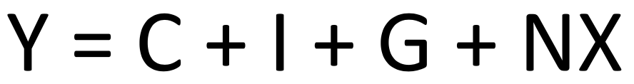

Let Net Export = 0 (a closed economy with no trade)



As  (Government spending = Government consumption + Government Investment)

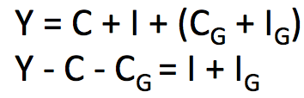

As Saving is GDP which is not consumed we have:

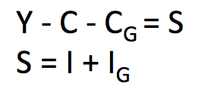

So, in a closed economy, national savings = national investment

* Introducing taxes we see that national savings is a combination of both private and government savings

Savings = GDP not consumed



Net taxes (T = taxes – transfers) which are paid from household’s income to the government, and national savings (S) is equal to private (SP) + public (SG) savings.

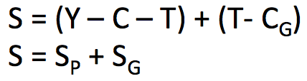

1. Private saving is the saving of the private sector of the economy and it is equal to the after-tax income of the private sector – consumption expenditures (Y-T-C); it can be further broken down into household saving and business saving.
2. Transfer payments are the payments the government makes to the public for which it receives no current goods or services in return.
3. Public savings is the saving of the government sector and it is equal to net tax payments – government purchases. (), it is part of government’s “budget balance”



1. The government budget can be in surplus:

* >0
* Excess of government tax collections over government spending
* Government budget surplus = public saving
* Repaying debt

1. Balanced

* =0
* Taxes and spending in a given year are equal

1. Deficit

* <0
* excess of government spending over tax collections
* Borrowing/increasing debt
* Public debt
* Australian current status:

1. Went into deficit (borrowing) in 2009 to stimulate the economy by reducing saving and increasing investment.
2. Household wealth has steadily increased (except for 2007-09 financial crisis)
3. Household saving less due to easy credit, compulsory super
4. Low household saving in Australia is not a serious problem as it is the total national saving that matters for capital formation, also the low household saving has been offset by increases in saving by firms in recent years
5. Falling nominal interest rate as inflation came under control
6. Capital gains from the share market increase the Australia’s household wealth and the value of the private housing stock

**Investment**

* Investment decision is made based on the cost-benefit principle:

Marginal benefit of investment >= Marginal cost of investment --- marginal product >= 0

* Investment is affected by taxes, cost of capital, interest rate.
* Even if the investment is financed internally, the interest rate is the opportunity cost of financing something else.
* Determinants of the level of investment:

1. Real interest rate
2. Taxation rate
3. Other impacts on revenues
4. Opportunity cost of alternative uses of its finance (increased real interest rates increase the opportunity cost)

**Supply and Demand**

* The equality of saving and investment occurs through financial markets, where the demand for saving (for investment) is made equal to the supply of saving through the price, which is the real interest rate.
* The demand curve for savings shows how the demand for investment funds, when all else is equal, varies with changes in the real interest rate
* The supply curve for savings shows how the supply of savings, when all else is equal, varies with changes in the real interest rate.
* Changes in factors other than the real interest rate that affect the supply of funds or demand for funds will shift the curves.
* The demand curve for savings is downward-sloping, meaning people are more willing to borrow money at lower real interest rates.
* The supply curve for savings is up-ward sloping, meaning people are more willing to save money at higher real interest rates.
* The financial market is in equilibrium when the demand curve for saving is equal to the supply curve of savings.
* 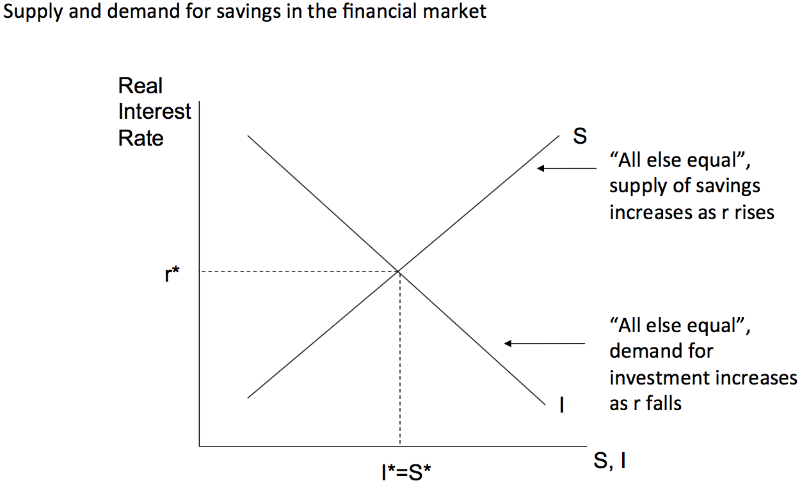
* The life cycle saving hypothesis says that people prefer to smooth their lifetime consumption by borrowing and dissaving --- we might expect future dissaving as the baby-boomers retire --- the supply of savings will fall, raising the real interest rate.

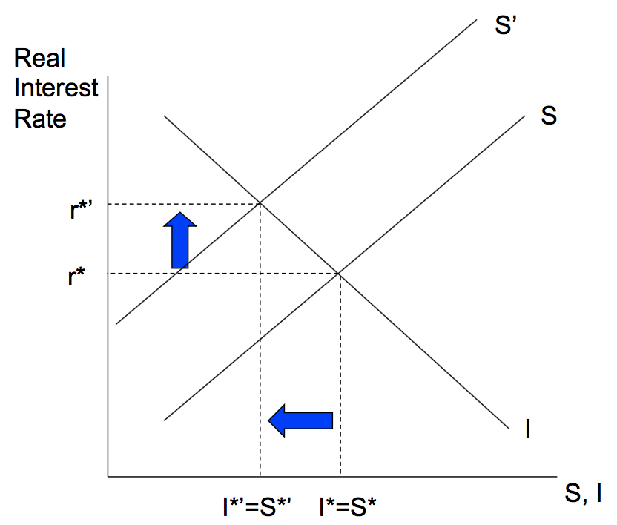

* Anything that changes the marginal product of the investment will shift the demand for investment funds. This is because:

1. Anything that decreases the marginal product of investment will reduce the demand for investment funds, at every interest rate level
2. Anything that increases the marginal product of the investment will increase the demand for investment funds, at every interest rate level.
3. Eg. The effects of new technology

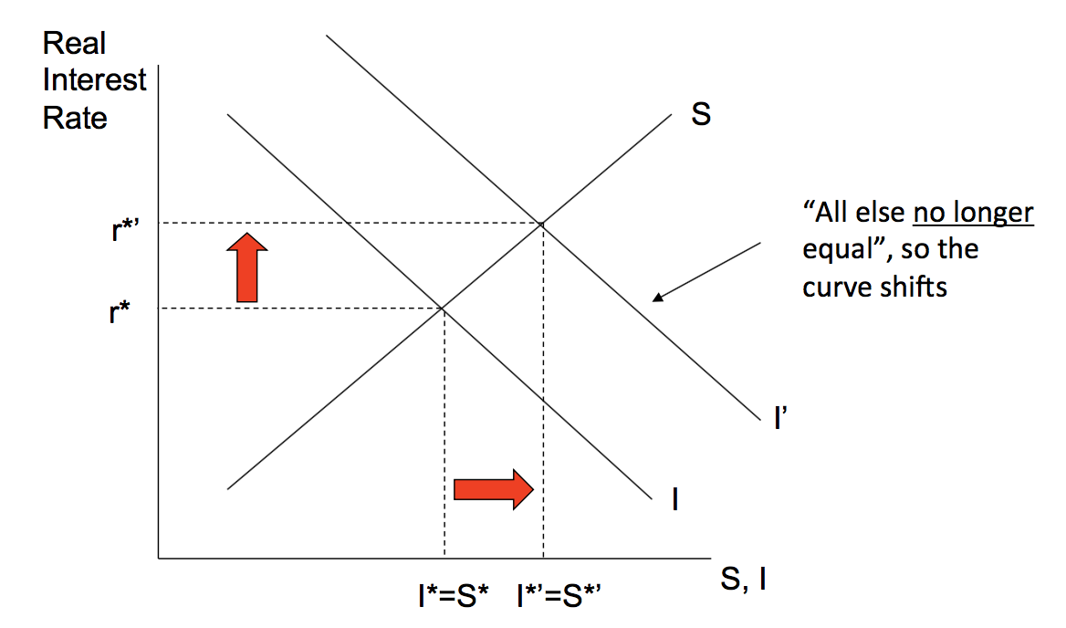

A positive technology shock will increase the returns to investment, raising the real interest rate and moving up the savings curve.

* Anything that changes the level of saving in the economy will shift the supply of savings. This is because:

1. As saving is made up of public and private saving, anything that makes households, businesses or governments choose to change their saving rate will shift the supply curve.
2. Eg. 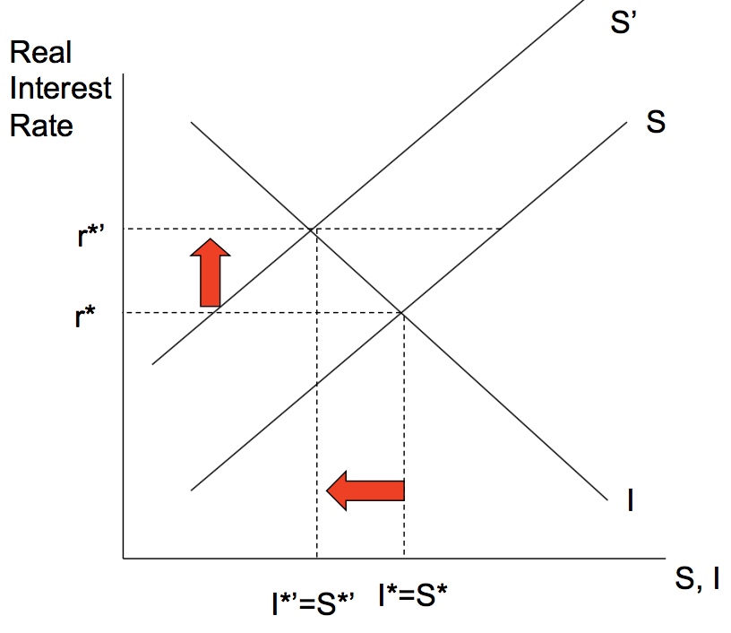

An increase of government budget deficit

**Questions:**

* 1. What is the relation between saving and wealth?
  2. For what reasons do people save?
  3. What had happened to the household saving ratio in Australia?
  4. What does national saving mean?
  5. How are investment and capital formation related?
  6. What roles does the real interest rate play in determining saving and investment?